
Society for Conservation Biology
EUROPE SECTION

http://www.conbio.org/Sections/EUROPE

ECCB 2012
BIODIVERSITY IN EUROPE
Messages to policy-makers from conservation scientists gathered in Glasgow
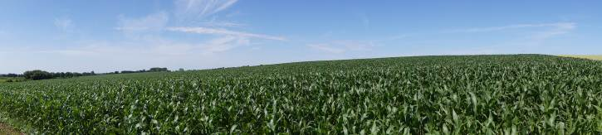 | ECCB expresses concerns about the on-going intensification and homogenization of agricultural landscapes across Europe and beyond. It calls for a robust and effective plan for sustainable land use that meets current and growing needs at both national and regional levels within Europe whilst safeguarding biodiversity and ecosystem function.
  Old growth forests are unique ecosystems that play a fundamental role in the provision of ecosystem goods and services and yet less than 2% remain throughout Europe. ECCB calls for the strict protection of the remaining tracts of old-growth forest (including the ecological processes that maintain them) together with other wilderness areas in the European periphery. It also advocates for the ecological restoration of potential wilderness landscapes. | 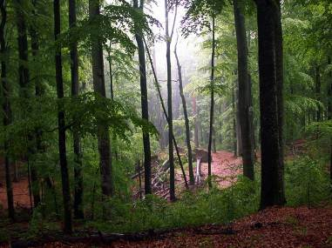
promote peace and strengthen common European values, Especially in times of economic and political crisis. ECCB calls for the intensification of trans-boundary cooperation, to be anchored in conservation strategies from regional to continental scales. | The establishment of an Intergovernmental Platform on Biodiversity and Ecosystem Services The aim of IPBES is to improve coordinate responses to the accelerated loss of biodiversity, impaired ecosystem services, and lack of policy action. ECCB supports this process by emphasizing the need for a systematic approach to deal effectively with uncertainty and other types of non-knowledge, which go beyond the existing knowledge gaps. In the absence of evidence, we call for full consideration of the precautionary principle.
  ECCB stresses that conservation across national borders should be seen as a cornerstone to linking peoples, societies and nations within the EU and beyond. Apart from the obvious need to protect nature, trans-boundary efforts to protect nature should be perceived as means to

WHERE DOES THIS MESSAGE COME FROM:

In September 2012 approximately 900 conservation scientists gathered together at the 3rd European Congress of Conservation Biology (ECCB) in Glasgow, Scotland. The Policy Committee of the Europe Section of the Society for Conservation Biology (SCB-ES) invited congress participants to vote on 10 clearly defined statements to help formulate a position which represents the values and opinions of the members. The 10 statements covered a wide array of current topics of European conservation policy. Over 160 congress participants took part in the vote. The results of the ballot, which summarize main messages emerging from symposia, oral and poster sessions received support of 67% of the voters, and should be regarded as the official “ECCB Policy Message from Glasgow”.

Contacts:
András Baldi: andrasbaldi@gmail.com - President SCB Europe
Pierre Ibisch: pibisch@hnee.de – Chair SCB Europe Policy Committee
Guy Pe’er: guy.peer@ufz.de – Chair SCB Europe Communication Committee

